|  |
| --- |
|  |
| Tutor Scheduler  User Manual |
| |  |  |  | | --- | --- | --- | | Alex Dixon & McKinsey Wilson |  | 12/6/19 | |

Contents

Table of Figures 2

1. Introduction 3

Overview 3

2. Getting Started 3

3. Logging In 4

4. Editing the Schedule 4

5. Managing Student Workers 5

6. Managing Subjects 8

7. Managing Schedules 9

## Table of Figures

Figure 1 - XAMPP Control Panel 3

Figure 2 - XAMPP Control Panel Services Running 4

Figure 3 - The Main Window 4

Figure 4 - Toggle Availability or Class Schedules 5

Figure 5 - Switch Calendar View 5

Figure 6 - Single Day Calendar View 5

Figure 7 - Manage Student Workers Menu Item 6

Figure 8 - Show/Hide Student Workers 6

Figure 9 - Select Student Worker 7

Figure 10 - Edit Student Worker 8

Figure 11 - Manage Subjects Menu Item 8

Figure 12 - Manage Subjects Window 9

Figure 13 - File Menu 10

# Introduction

## Overview

Tutor Scheduler is a schedule management system specifically for student tutors. It can manage student worker class schedules and work schedules to ensure work schedules meet certain criteria and do not interfere with class schedules. It can also manage which subjects are tutored by each student worker to summarize schedule information by subject coverage and simplify schedule management. Tutor Scheduler also includes a PHP web application to allow student workers to view and edit their own class schedules by logging in with their student ID. All information is stored on a server in a relational database so once fully deployed, the client application can run on multiple client machines while sharing information through the server.

# Getting Started

Currently, Tutor Scheduler is configured to use a MySQL database located on localhost. To run MySQL on the localhost for a Windows machine, first download XAMPP from the following link:

<https://www.apachefriends.org/download.html>

After installing XAMPP, open the XAMPP control panel and start the services “Apache” and “MySQL.”

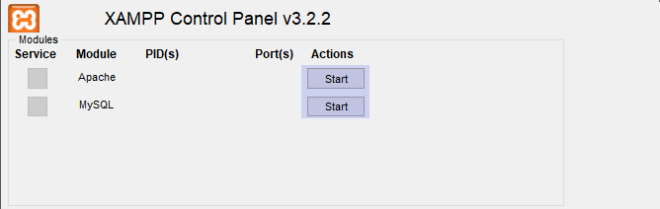

Figure - XAMPP Control Panel

Once both of these services are running, you are ready to begin using Tutor Scheduler by running TutorScheduler.exe.

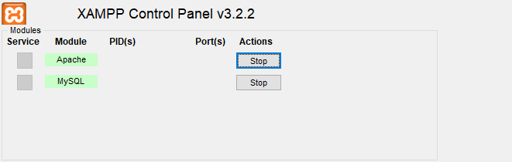

Figure - XAMPP Control Panel Services Running

# Logging In

After starting Tutor Scheduler, the login window will be displayed. In the username text box, enter:

lara1

and in the password text box, enter;

password

then click the Submit button to log in. The main window will then be displayed.

# Editing the Schedule

The main window shows the current schedule. The default view is week view, with only class and work events visible.

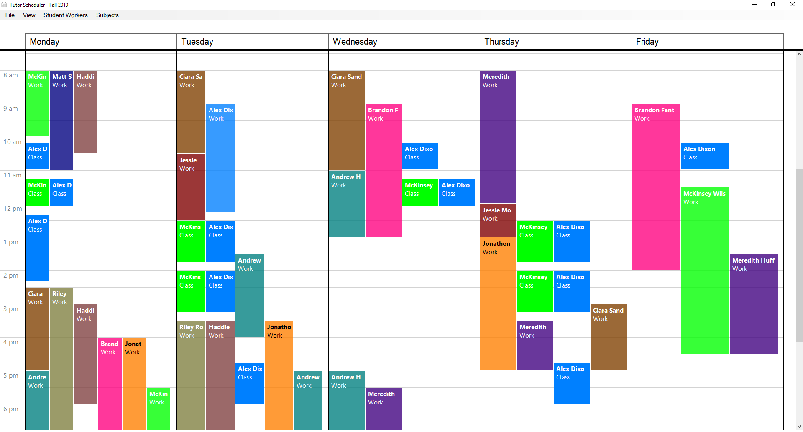

Figure - The Main Window

You can toggle visibility of the availability and class schedules by selecting either item from the View menu. The corresponding item will show a checkmark when the schedule is currently visible.

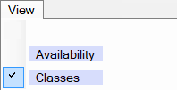

Figure - Toggle Availability or Class Schedules

You can toggle between day or week view for the calendar with the item in the View menu.

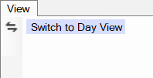

Figure - Switch Calendar View

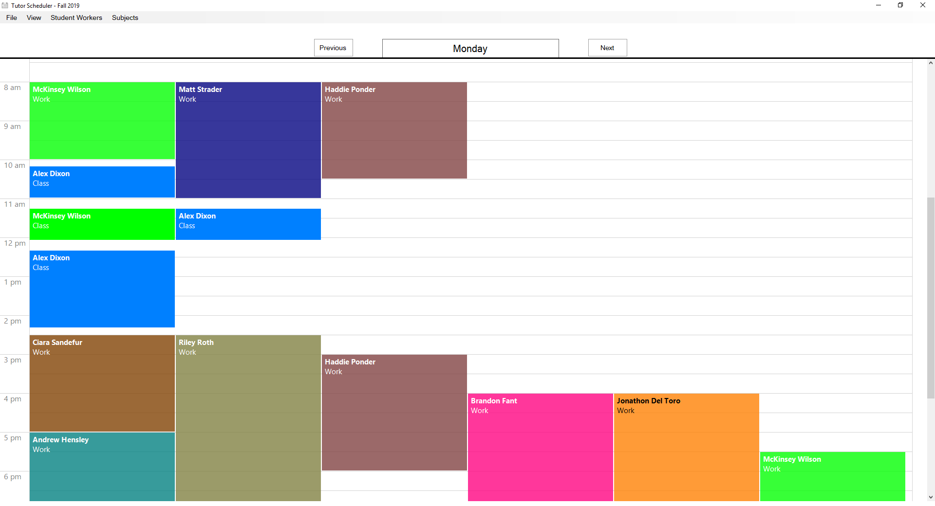

Figure - Single Day Calendar View

# Managing Student Workers

You can manage student workers for the current schedule by selecting “Manage Student Workers” under the Student Worker menu.



Figure - Manage Student Workers Menu Item

You can select which student workers to show or hide on the calendar using the checkboxes on the left side. The checkbox at the top of the column will check or uncheck every checkbox at once.

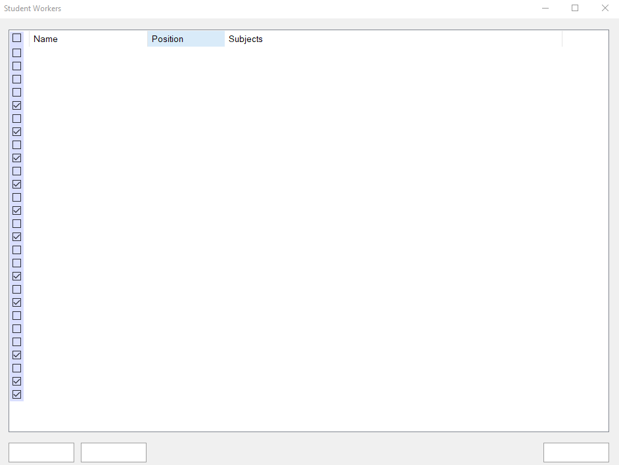

Figure - Show/Hide Student Workers

Click on a student worker to select them or double-click on a student worker to edit their information, including name, job position, display color, subjects tutored, and class schedule.

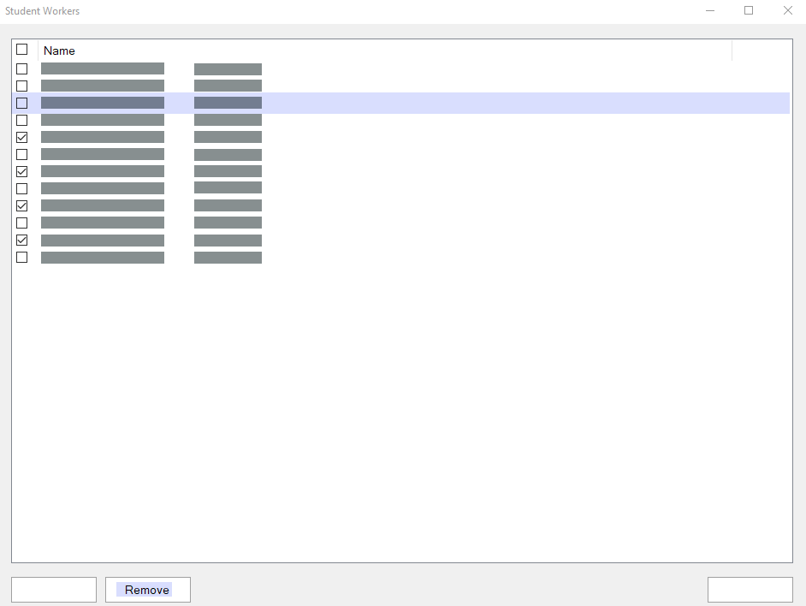

Figure - Select Student Worker

If a student is selected, you can click the Remove button to remove them from the current schedule. You will be prompted to confirm this action before it is completed. This will only remove them from the current schedule, and they will not automatically be added to subsequent schedules. They will still be included in other schedules they have been assigned to.

After double-clicking a student worker, their information window will be displayed.

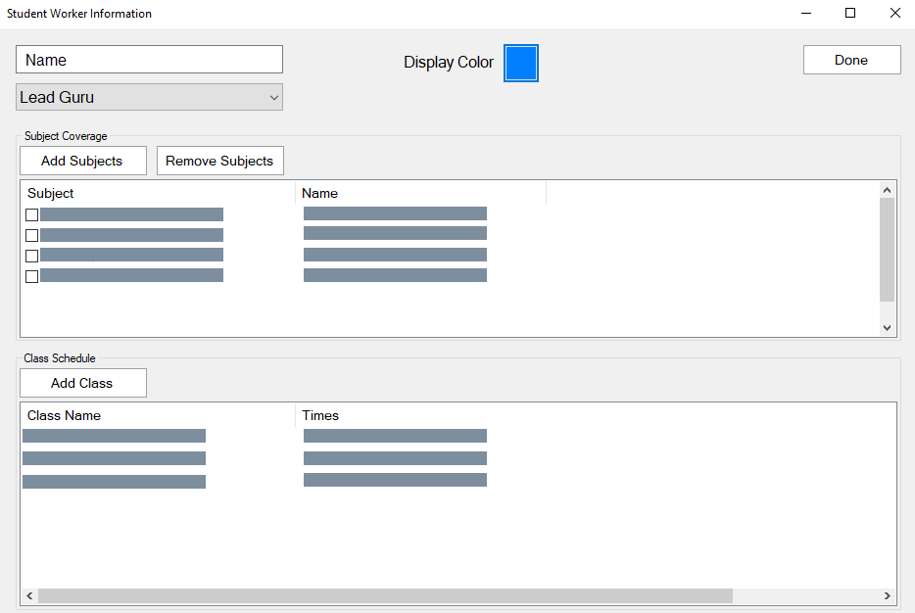

Figure - Edit Student Worker

From this window, you can change the name with the text box or the job position with the drop-down box. Click the color box next to “Display Color” to select a new display color from the system color picker. Click the Add Subjects button to assign subjects to the student worker. Select one or more subjects from the list with the checkboxes, then click the Remove Subjects button to unassign the selected subjects from the student worker. The subjects will not be removed from the system, they will just be unassigned from this student worker. To edit the class schedule, click the Add Class button and the new class window will be shown.

# Managing Subjects

To manage subjects, select Manage Subjects from the Subjects menu.



Figure - Manage Subjects Menu Item

From the Manage Subjects Window, you can create new subjects, remove subjects from the system, select which subjects to show or hide student worker schedules for, or view subject flyers.

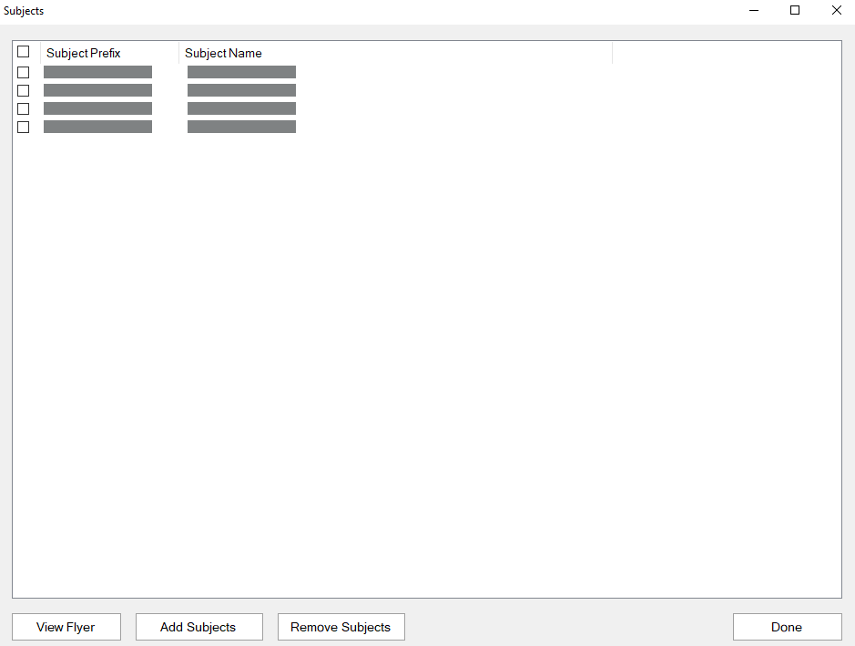

Figure - Manage Subjects Window

Use the checkboxes on the left side to select subjects to view the student worker schedules for. For every subject checked, all the student workers who tutor the subject will have their schedule displayed on the calendar. Click the Add Subjects button to create a new subject in the system. Select a subject from the list and click the Remove Subjects button to remove the selected subject from the system. This will unassign the subject from all student workers it is assigned to and remove it from the system. You will be prompted to confirm this action before it is completed. To view a subject flyer, select a subject and click the View Flyer button.

# Managing Schedules

To create a new schedule, select New Schedule from the File menu. You will be prompted to name the schedule before it is created. To open a different schedule, selected Open Schedule from the File menu, then select the schedule you wish to open.

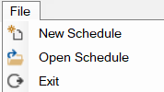

Figure - File Menu